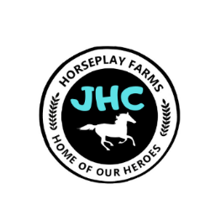
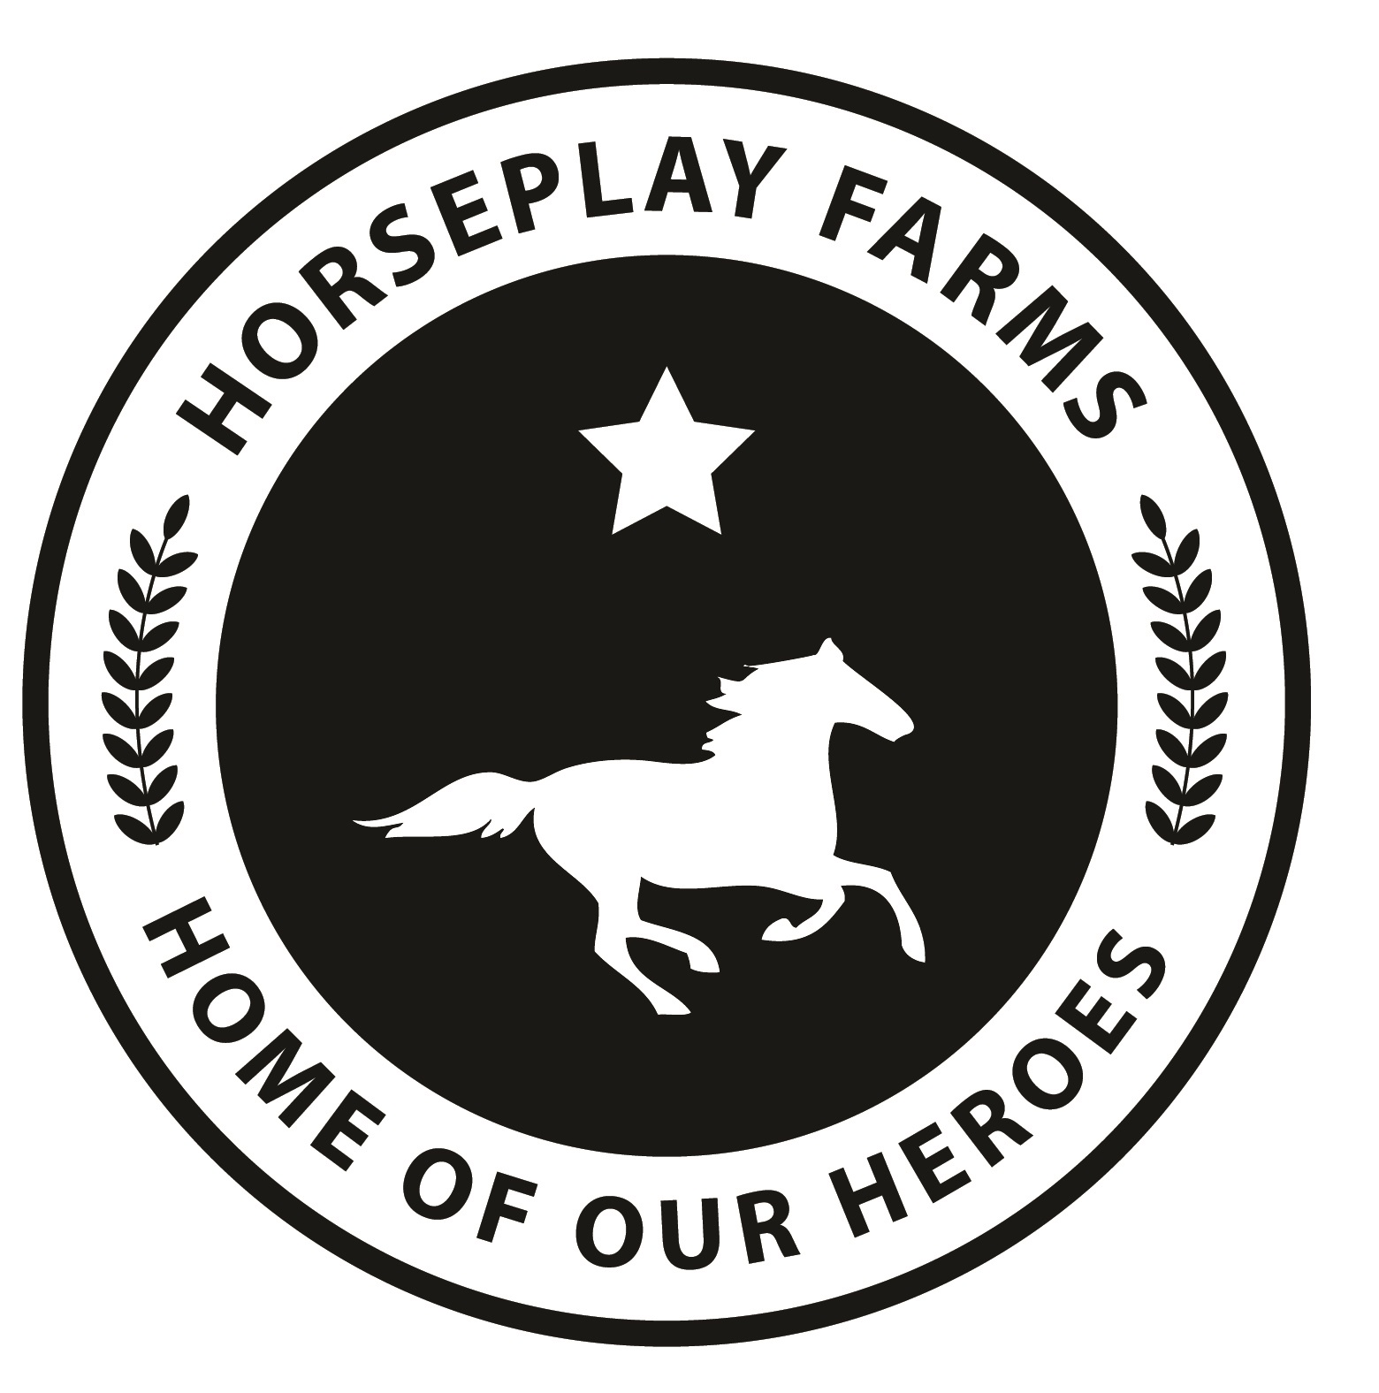
Jr. Horsemanship Club
& Rider’s Registration 2023

No individual can be accepted for riding at Horseplay Farms, LLC, Inc. until this form has been completed by the
by the rider (if legally competent and over the age of 18) or the rider’s parent or legal guardian (if the rider is under the
age of 18 or has special needs).

There is no registration fee to join the Junior Horsemanship Club. There is a fee of $5 per child, per weekly session.
Registration Date:
RIDER INFORMATION: □ Permanent Resident □ Out of Town Visitor/How Often? _________________
Full Name: ________________________________________
Date of Birth: _________________________
Street Address: __________________________________________
City: _____________________________ State: ___________ Zip: __________________
Rider’s Height: _____________ Weight: ________________ (used for matching horses)
Does the rider have previous experience riding horses? □ None □ Some/Casual □ Extensive
Briefly Explain: __________________________________________________________________________________
Riding Discipline: □ English □ Western □ No Preference
Does the rider have any medical conditions (allergies, ADHD, etc.) we should know about? Briefly Explain: _____________________________________________________________________
parent/guardian(s) Full Name: ____________________________________________________________
Street Address: ______________________________________________________State__________Zip___________
Email Address ____________________________Home Phone(____) ______________Cell Phone(____)____________
Emergency contact in absence of parent/guardian
Full Name: ___________________________________ Relation: _______________________________________
Home Phone: (____) _________________ Cell Phone: (____) __________________
Authorization to provide emergency medical treatment
In the event of a medical emergency or illness while participating in services of Horseplay Farms, LLC
I authorize Horseplay Farms to secure and retain medical transportation and/or treatment for myself or my child/ward. The emergency contact listed above will be contacted. I authorize Horseplay Farms LLC to use the information provided on this form to assist in the emergency medical treatment of myself or my child/ward.

Signature: _______________________________________________________ Date: __________
Preferred Emergency Medical Facility: _________________________________________________ (See page 2)

Horseplay Farms Jr. Horsemanship Club & Rider’s Registration 2023 (page 2 of 2)
Knowledge of risk, acceptance of responsbility, & release of liability
This release is valid in all legal proceedings.

I,_______________________, (parent of _________________________________________ ) hereby affirm that I am aware of the inherent hazards of horseback riding and other farm-related activities. I understand and agree that Horseplay Farms, LLC may not be held liable or responsible in any way for injury, death, or other damages to me or my family or my property, heirs, or assigns that may occur as a result of my participation in this farm- related activity or as a result of the negligence of any party, whether active or passive.
____In consideration of being allowed to participate in this activity, I hereby personally assume all risks in connection with said activity, for any harm, injury, or damage that may befall me or my property while so engaged, including all risks connected therewith, whether foreseen or unforeseen. I understand that if an injury does occur that only my own personal health insurance or other insurance will be involved in a claim.
____I further release and hold harmless said activity, horse’s owner, and Horseplay Farms, LLC from any claim or lawsuit by me, my family, estate, heirs or assigns, arising out of my participation in this activity, including both claims arising during the activity and/or before or afterwards.
____I also understand that horse-related activities may be physically strenuous and that I may be exerting myself during this activity. I further understand that horses, dogs, cats, wildlife and nature itself may behave in unpredictable and potentially dangerous ways. I expressly assume the risk of injuries resultant from my participation in these activities and I will not hold responsible Horseplay Farms, LLC in any way. I further state that I am of lawful age and am legally competent to sign this liability release.
____I understand that the terms and conditions of this release are contractual and not a mere recital, and that I have signed this document of my own free act.
NORTH CAROLINA EQUINE LIABILTY LAW Under North Carolina Law, an equine activity sponsor or equine professional is not liable for an injury to or the death of a participant in equine activities resulting exclusively from the inherent risks of equine activities.
Chapter 99E of the North Carolina Statutes
I HAVE FULLY INFORMED MYSELF OF THE CONTENTS OF THIS LIABILITY RELEASE AND EXPRESS ASSUMPTION OF RISK BY READING IT BEFORE I SIGNED IT ON BEHALF OF MYSELF AND MY HEIRS.
Printed Name of Rider: ____________________________________________________________________

Printed Name of Parent/Guardian ____________________________________________________________

Signature of Parent/Guardian ____________________________________________ Date: ______________

photo release form
After valuable consideration which is hereby acknowledged to be sufficient, the undersigned hereby grants permission to Horseplay Farms, LLC and Our Heroes, Inc. to take or have taken still and moving photographs and films, including television footage, of the following individual:
The undersigned hereby consents and authorizes Horseplay Farms, LLC and Our Heroes, Inc. to use and reproduce photographs, films, and footage to circulate and publicize by all means including but without limit to the generality of newspapers, television media, internet promotion(s), Facebook, YouTube, blogs and websites, brochures, pamphlets, instructional materials, books and clinical/therapeutic materials. With regard to the foregoing material, no compensation was agreed upon or promised and it is with the full and uninduced consent that Horseplay Farms, LLC and Our Heroes, Inc. can use media representation of the undersigned for the purpose of promoting and aiding Horseplay Farms, LLC. and their work.
Rider’s Name: _______________________Date:___________ Consent for Photographs (Check one): □ Yes □ No
Signature of Parent/Guardian ____________________________________________ Date: ______________

